# Understanding VPNs for Privacy and Secure Communication

## 1. Introduction

A Virtual Private Network (VPN) is a secure tunnel that encrypts your internet connection and masks your IP address, enhancing privacy and protecting data from snooping or tracking. This project explores how VPNs work and demonstrates the use of a free VPN service for secure browsing.

## 2. Tools Used

- VPN Client: ProtonVPN (Free Tier)  
- Browser: Google Chrome  
- IP Checker: https://whatismyipaddress.com

## 3. VPN Setup Steps

Step 1: Sign Up  
- Visit https://protonvpn.com and sign up for a free account.

Step 2: Download and Install  
- Download the ProtonVPN client for your OS (Windows/Mac).  
- Install the application and log in using your credentials.

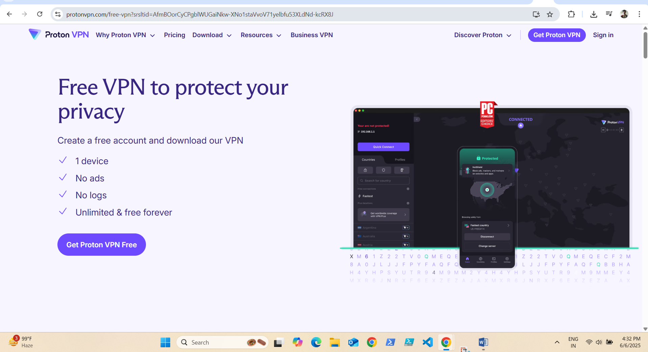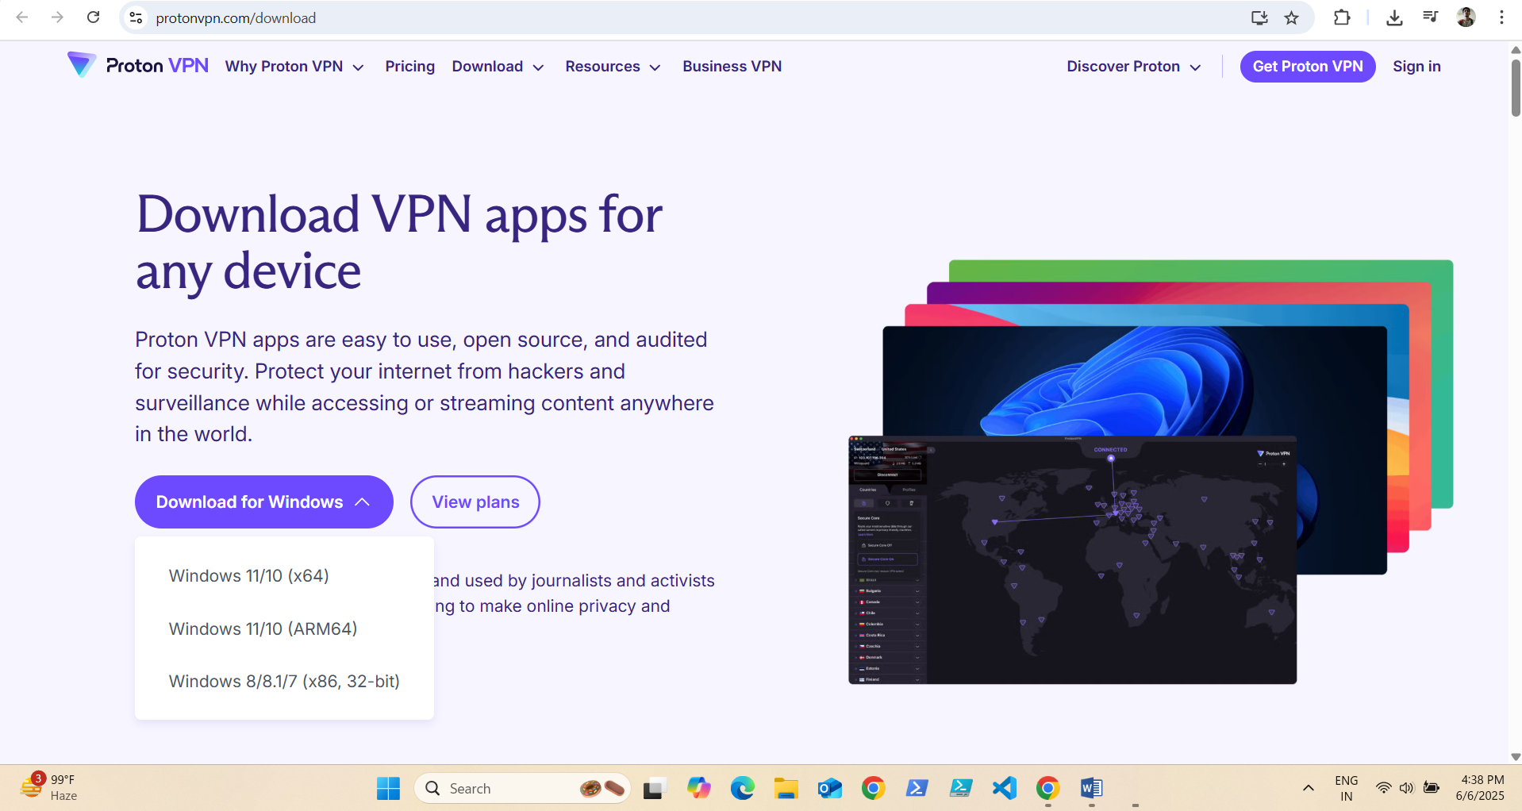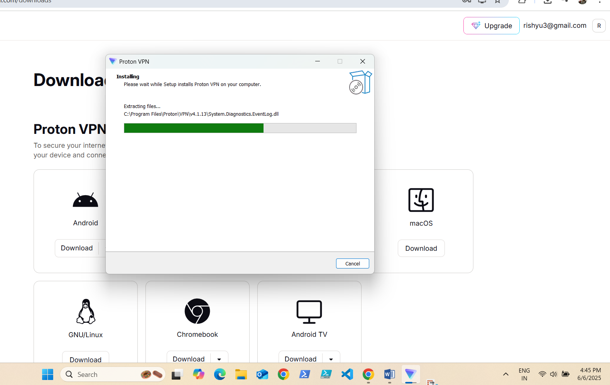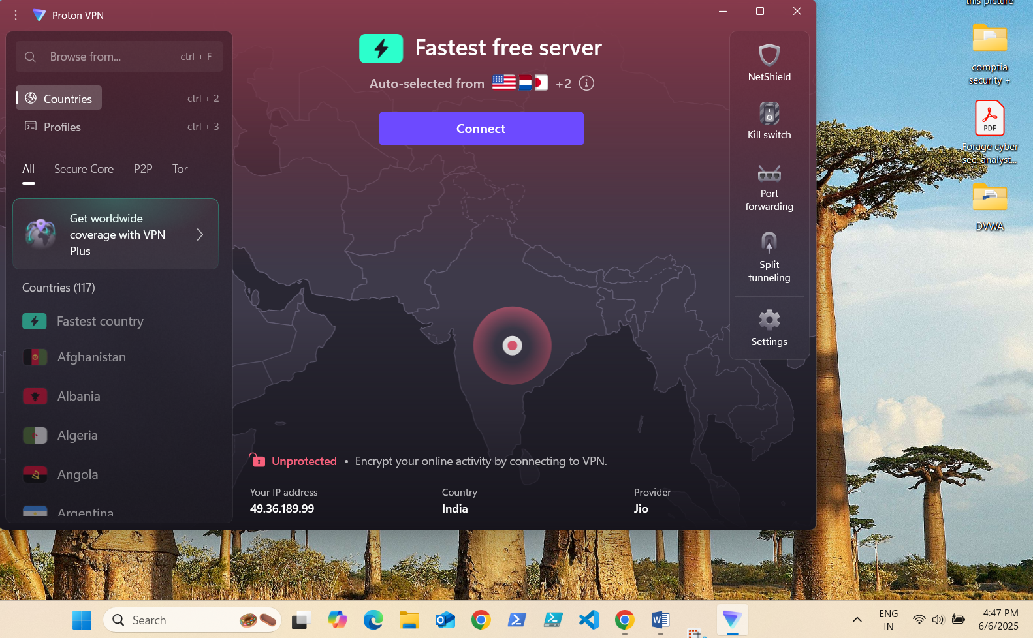

Step 3: Connect to a Server  
- Click on a country/location (choose the closest one for better speed).  
- Connect to a VPN server.

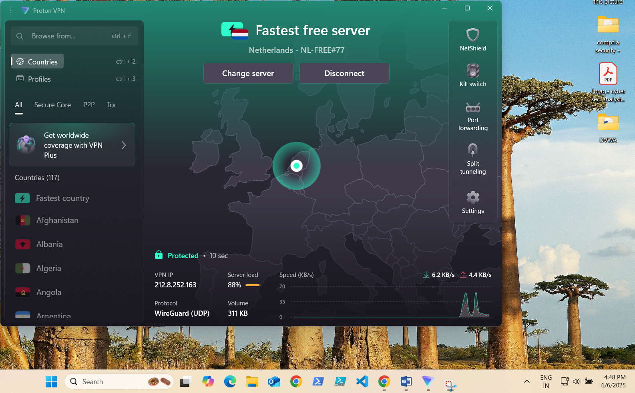

Step 4: Verify IP Address Change  
- Go to https://whatismyipaddress.com  
- Confirm your IP address is different from your original IP.

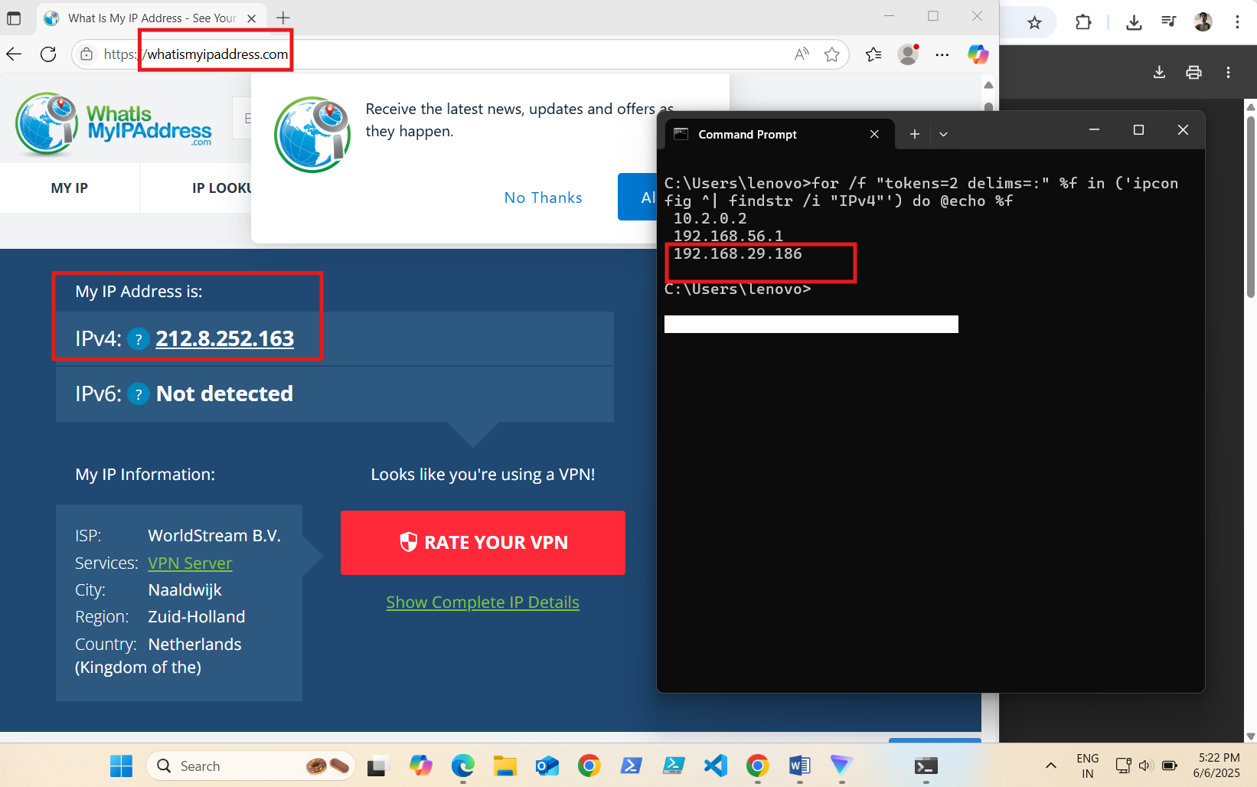

## 4. Browsing Test (Encrypted Traffic)

Open any website like https://example.com.  
Confirm it loads correctly and speed is reasonable.

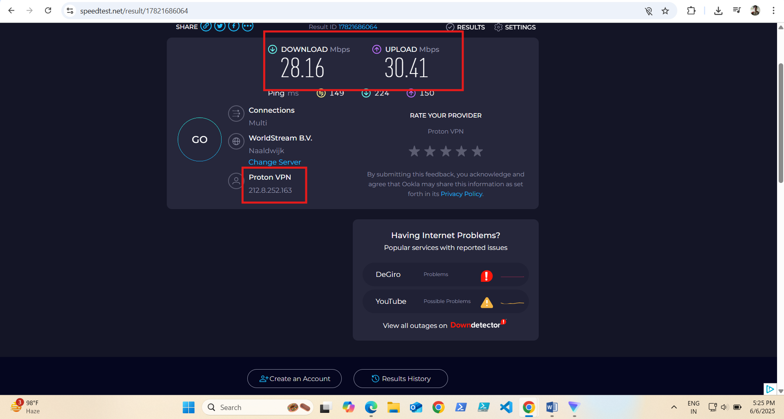

## 5. VPN Disconnect & Comparison

Disconnect from ProtonVPN.  
Check your IP address again on https://whatismyipaddress.com.  
Try opening the same website and compare browsing speed.

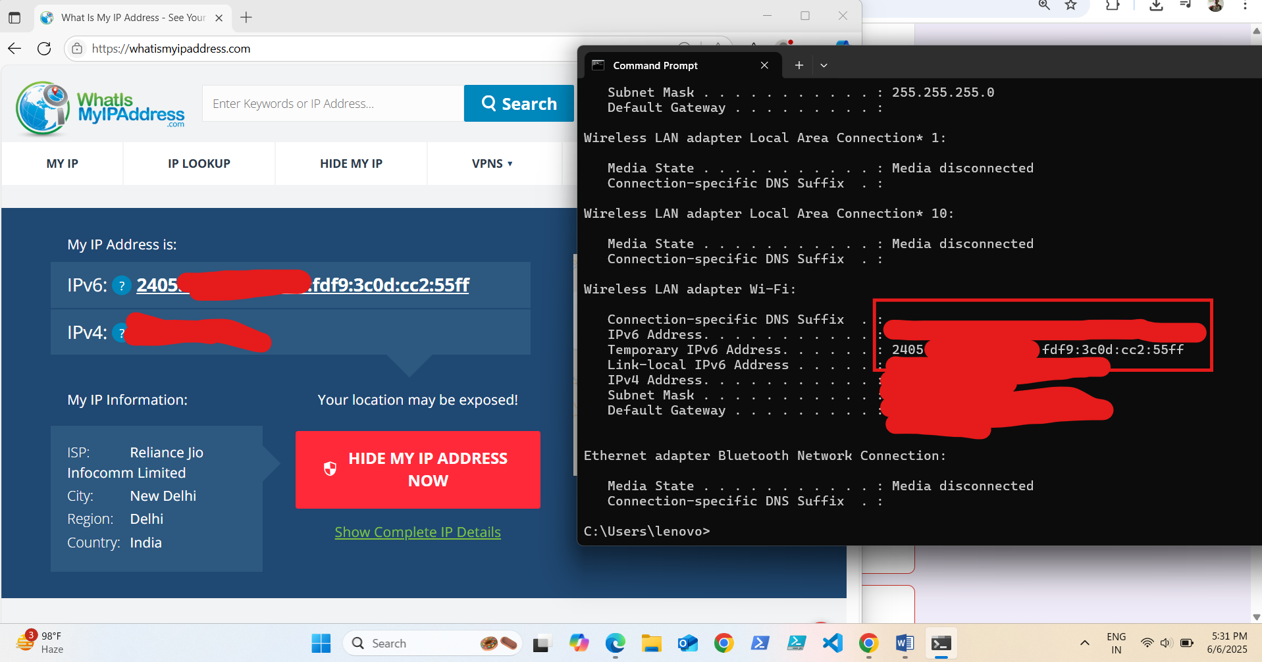

## 6. Research: VPN Encryption and Privacy

- ProtonVPN uses AES-256 encryption.  
- It follows a no-logs policy (does not store your browsing data).  
- Encrypts DNS queries and hides IP address.  
- Useful against ISP tracking, public Wi-Fi snooping, and geo-blocking.

## 7. Benefits of Using a VPN

- Privacy: Hides IP address and browsing activity.  
- Security: Protects data on public Wi-Fi.  
- Bypass Censorship: Access blocked websites/content.  
- Prevent Tracking: Stops trackers and ads from profiling users.

## 8. Limitations of Free VPNs

- Speed: May be slower than paid VPNs.  
- Server Availability: Fewer servers or locations.  
- Data Limits: Some free plans have usage caps.  
- Not Fully Anonymous: Still depends on VPN provider's policy.

## 9. Conclusion

VPNs play a critical role in securing online activities and protecting personal privacy. While free VPNs like ProtonVPN provide basic protection, premium plans offer more features and better performance.